We’re excited to have you join us for the Data Science for the Public Good 2023 Young Scholars program!

We have a few general updates for everyone, as well as some important information that we need from you, so please read this material carefully!

Updates and Information Requests

First, everyone's hiring paperwork is moving through the Biocomplexity Institute's internal process and (our hope) is that you'll hear back from UVA's central HR group by May 1. If you don't, please let us know!

Program hours and expectations

Our expectation is that you’ll be with us for 40 hours each week for the entire 10 weeks from Tuesday, May 30 to Friday, August 4. The core hours for the program are from 9:00 AM to 4:00 PM to ensure that everyone is generally in the office at the same time. There’s an hour of flex time on either side in case you’d prefer to come in a little earlier or stay a little later.

The workday will be a mix of in-house seminars & training, external speakers, and plenty of project time. We’ll have a more detailed schedule ready to share with you when you arrive.

Except for university holidays (i.e., May 30, June 19, July 4) there are no vacation days associated with the program. However, if you need to be away or out of town for any reason, let Joel and Cesar know. We’re flexible, and we can almost always accommodate someone that needs to leave early for a weekend trip, arrive late due to a doctor’s appointment, etc.

Projects

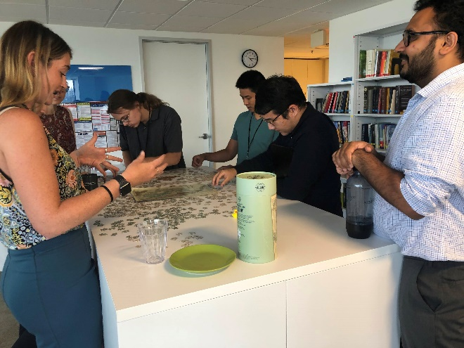
Our plan is to have everyone work on one primary project alongside our research staff. You can read more about some of our ongoing projects on our website below.
DSPG 2022 hard at work at our puzzle table.

Each project will involve different amounts of data discovery, data wrangling, statistical analysis, visualization, and presenting results (internally and to our sponsors).

SDAD website: https://biocomplexity.virginia.edu/institute/divisions/social-and-decision-analytics/projects

Additionally, we’re trying something new this year with a secondary project that the entire DSPG cohort will contribute to. While our other projects will be closely integrated with our existing sponsored work, the DSPG only project is one we’re doing in conjunction with Biokind Analytics: https://www.biokind.org/. The primary stakeholder will be Alex Han, the Rice University student that started the organization, and there will be a lot of freedom on your part to shape how that work unfolds.

Be ready for the I-9 process!

The university is getting serious about paperwork, especially the I-9 process. We’ll be looking to take care of that as the very first thing we do on day 1.

You can read more about that process at the following website, as well as what documents you’ll need to have in hand when you arrive at the office on Tuesday, May 30 at 9 AM.

UVA I-9 website: https://hr.virginia.edu/compliance/i-9-and-e-verify

What kind of computer do you have?

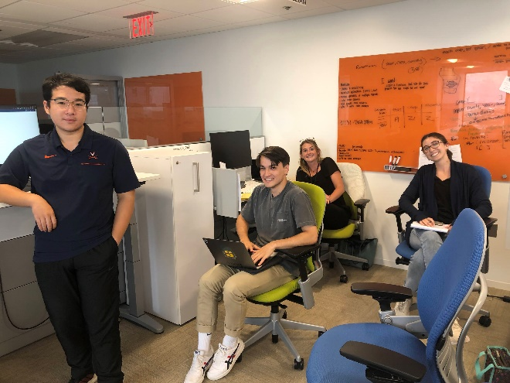
We need to know what kind of computer you’ll be bringing with you (i.e., PC or Mac) so we can ensure we have the proper peripherals for you (e.g., monitors, keyboards, mice).
Taking time out from work to pose for the camera.

Please complete the survey using the following link to indicate what type of computer you will be bringing with you this summer.

In addition, we’d like to put together a small welcome package for all of you, but rather than surprise you with it, we’d like your help in picking out things that would be most useful to you.

Survey link: https://forms.office.com/r/i66VnbffMi

Additional questionnaires

A few weeks out from the program, we’ll be sending out a link to an intake survey that will help us better anticipate your interests in skill and professional development throughout the program. A component of this survey includes an ongoing team science research project that we’ve been running in conjunction with DSPG throughout the last few years. Even if you opt not to make your responses available for the research component, we ask that you do fill out the entirety of the questionnaire for program development purposes.

Your responses will help us ensure we assign you to a project, select an appropriate mentor for you, and help us continue to refine the program moving forward for future participants.

Questions, Comments, Concerns

If you have any questions or other information you’d like to share, please don’t hesitate to reach out to Joel and Cesar, the DSPG coordinators.

Joel Thurston: jt9sz@virginia.edu
Cesar Montalvo: cpm9w@virginia.edu

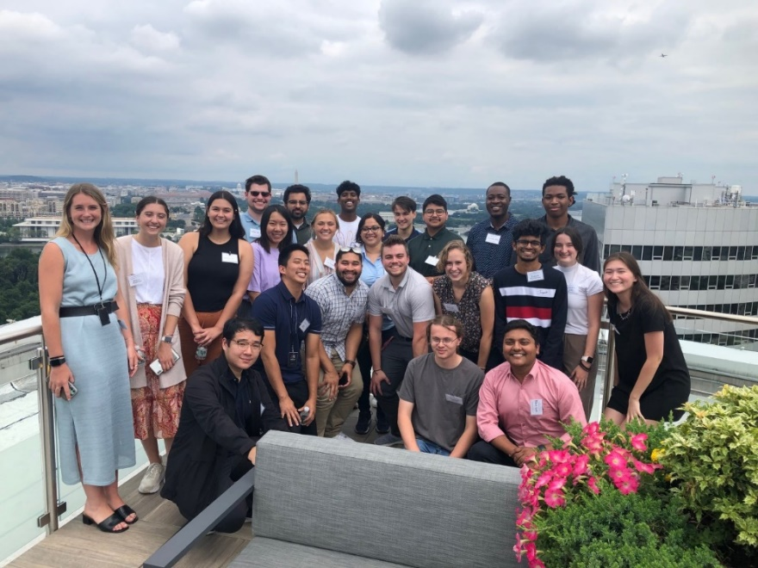
UVA DSPG 2022 hosts participants from our sister program at VT and visits the roof deck.
Housing and Transportation Information

Since we will be running the program as an in-person experience, you'll want to locate housing in the area. Unfortunately, we don't have any official housing associated with the DSPG program, but we've sourced ideas from past participants and other members of our staff.

Local colleges and universities were a popular suggestion. Both George Mason and George Washington rent bedrooms in their residence halls, and previous participants have stayed in both places (I believe):
- George Mason University - https://housing.gmu.edu/summer-mason
- George Washington University - https://summerhousing.gwu.edu/
Other colleges and universities in the area likely have summer housing options too. There are also groups on Facebook that have information on available rooms, sublets, etc.:
- Washington D.C. Housing, Rooms, Apartments, Sublets Facebook group: https://www.facebook.com/groups/1468086266815937/
- DC, Northern Virginia, and Maryland Housing, Sublets, and Roommates Facebook group, which is similar to the other group but covers a wider geography: https://www.facebook.com/groups/arlingtonfairfaxrentals/

There may be other Facebook or social media groups for smaller neighborhoods as well. Past participants have also had luck finding housing through the usual means (e.g., Craig's List, Zillow, and other apartment apps).

Public transportation

When considering a location, you'll also want to consider transportation. Our office is right across the street from the Rosslyn metro station at 1100 Wilson Blvd, Arlington, VA 22209. The Rosslyn metro station is accessible by the Orange, Silver, and Blue metro lines. There are also a lot of bus routes that stop there. All the bus and metro lines across the greater DC area use the same transit card, so it's easy to transfer between systems.
If you're going to stick with public transportation, we recommend housing that's walkable to one of the metro lines mentioned or a bus route running to Rosslyn. Transferring bus-to-bus or metro-to-metro will extend your commute time but may still be manageable depending on personal preference.

For example, Joel lived at the last stop on the Yellow line in Huntington for over a year. That connected directly with the Blue line, and the commute (given the transfer, plus the physical distance involved) took about an hour each way. This is also (probably) the easiest type of transfer to make since both trains stop at the exact same platforms south of Arlington.

However, the Yellow line is currently out of service due to renovations, and it may not be operational this summer. They've extended Blue line service to cover the area, and you should check the WMATA site to get the latest info about this situation.

You can find maps of the various metro and bus routes, as well as updates on summer station closures, on this website: https://www.wmata.com/ .

If you’re interested in commuting by bicycle, be sure to check out the following link for information like maps and locations of bikeshare stations and pricing: https://www.bikearlington.com/

Personal vehicles and parking

Unfortunately, there's no free parking on the premises. If you want to drive, the cheapest parking options are 'early bird' specials with parking garages that offer $9-10 per day pricing if you arrive before 9 or 10 AM (depending on the garage). Most garages will charge $15-16 dollars for daily parking for later arrivals. There are also some 12-hour meter spots nearby, but if you pay for a full day of parking there, it will cost more than the lot rates.

Coordinating housing with fellow participants

Some participants have expressed interest in coordinating housing if possible, so feel free to reach out to each other directly about this, although we’re happy to help facilitate things if we can!

